Draft Description:  
11th SPE Comparative Solution Project

Jan M. Nordbotten[1], Martin Fernø[2], Bernd Flemisch[3], Anthony Kovscek[4], Knut-Andreas Lie[5]

# Technical description CSP 11C

The CSP 11C is a 3D geometry, set at field scale and conditions, typical of the Norwegian Continental Shelf.

## 4.1 Relationship to CSP 11B

The CSP 11C is an arched 3D extrusion of CSP 11B, as illustrated in Figure 3.

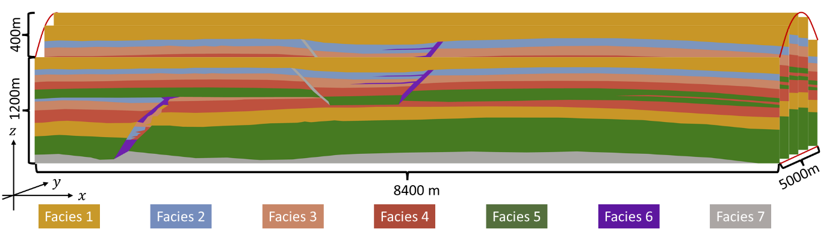

**Figure 3**: A sketch of the benchmark geometry for CSP 11C. For a detailed description, please refer to the text below and to caption of Figure 1. Two suggestions are provided, text associated with the top and bottom version is differentiated by red and blue.

We summarize the commonalities and differences between CSP 11B and 11C as follows:

1. The governing equations and facies properties for CSP 11B apply to 11C.
2. The geometry of CSP 11B is reused in CSP 11C, with the following modification: The depth (along the y-axis) is extended to 5000 meters, and deformed such that the top surface forms a parabola elevating the central part of the domain by 400m 150m, while the bottom surface remains flat. See section 4.2 for precise definition.   
     
   We emphasize that we keep the coordinate system oriented with the vertical direction pointing “up” and the origin in the “lower-left” corner of the domain, using the convention that the two horizontal axis are enumerated first, i.e. with reference to figure 3 coordinate triplets are given as $(x,y,z)$.
3. The geometric scaling affects the definition of Boxes A, B and C, and the well placements, as detailed in section 4.2.
4. The initial and boundary conditions, together with the injection schedule, are updated to be consistent with the 3D extension, see specification below.

## 4.2 Definition of geometry, well placement and reporting boxes

For a precise definition of the geometry, we consider a reference and a physical configuration, with a mapping between them.

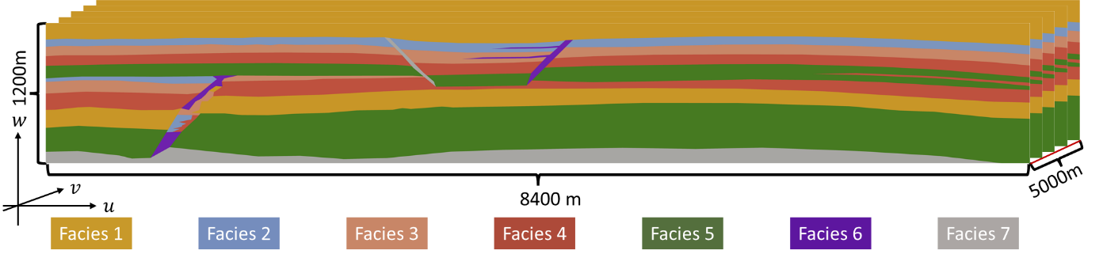

**Figure 4**: A sketch of the benchmark geometry for CSP 11C in the reference configuration.

Reference configuration: Let $U=\left[0, 8400\right]×\left[0, 5000\right]×\left[0, 1200\right]$ be the extrusion of the geometry from 11B to a depth of 5000 meters, as shown in Figure 4.. I.e., for any coordinate triplet $\left(u,v,w\right)∈U$, the facies properties are defined only by the first horizontal coordinate $u$ and the vertical coordinate $w$, according to the geometry defined in Section 3.1.

Mapping: For any reference coordinate triplet $u=\left(u,v,w\right)∈U$ in the reference configuration, we identify a position in physical space as:

|  |  |  |
| --- | --- | --- |
|  | $$\left(\begin{matrix}x \\ y \\ z\end{matrix}\right)=Φ\left(u,v,w\right)=\left(\begin{matrix}u \\ v \\ w\left(\frac{4}{3}-\frac{1}{3}{\left(\frac{v-2500}{2500}\right)}^{2}\right)\end{matrix}\right)$$ $$\left(\begin{matrix}x \\ y \\ z\end{matrix}\right)=Φ\left(u,v,w\right)=\left(\begin{matrix}u \\ v \\ w+150\left(1-{\left(\frac{v-2500}{2500}\right)}^{2}\right)\end{matrix}\right)$$ |  |

I.e., the domain is arched in the $y$-direction, such that A) the bottom boundary ($z=w=0$) is flat; B) the near and far boundary ( $y=v=0$ and $y=v=5000$) are unstretched with $z=w$, and C) the central part ($y=v=2500$) is stretched by 400 meters (about 33%) to a total height of 1600 meters.

I.e., the domain is arched in the $y$-direction, given a parabolic shape with maximum elevation difference of 150 meters at the central ridge of the domain ($y=v=2500$).

We note that $Φ\left(u,v,z\right)$ is an invertible function for the domain of interest $X=Φ\left(U\right)$, and we denote the inverse as $Ψ=Φ^{-1}$. Thus for any physical coordinate triplet $x=\left(x,y,z\right)∈X⊂R^{3}$, we can recover the position in reference configuration as:

|  |  |  |
| --- | --- | --- |
|  | $$\left(\begin{matrix}u \\ v \\ w\end{matrix}\right)=Ψ\left(x,y,z\right)=\left(\begin{matrix}x \\ y \\ z{\left(\frac{4}{3}-\frac{1}{3}{\left(\frac{y-2500}{2500}\right)}^{2}\right)}^{-1}\end{matrix}\right)$$ $$\left(\begin{matrix}u \\ v \\ w\end{matrix}\right)=Ψ\left(x,y,z\right)=\left(\begin{matrix}x \\ y \\ z-150\left(1-{\left(\frac{v-2500}{2500}\right)}^{2}\right)\end{matrix}\right)$$ |  |

Physical configuration: The facies distribution, as well as location of boundaries, for positions $x∈X$ in the physical configuration can now be obtained based on the facies distribution, and boundaries, of the reference configuration and the mapping $Ψ$.

The boxes are adjusted to account for the 3D configuration. We state the $(x,y,z)$ coordinates of the three boxes (measured relative to the lower left corner of the domain) in terms near bottom left and far top right corners:

Box A: Near bottom left (3300, 0, 0), far top right (8400, 5000, 800)

Box B: Near bottom left (0, 0, 800), far top right (3300, 5000, 1600)

Box C: Bottom left (3300, 1000, 0), top right (7800, 4000, 433)

Box A: Near bottom left (3300, 0, 0), far top right (8400, 5000, 750)

Box B: Near bottom left (0, 0, 750), far top right (3300, 5000, 1350)

Box C: Bottom left (3300, 1000, 0), top right (7800, 4000, 550)

Note that the definition of Box B (and Box C) extends outside the top (and respectively bottom) boundary, and the actual Box B (and Box C) can be truncated to the part within the physical domain $X$.

The two injection wells are considered as straight (horizontal), and are open/perforated between the near and far points with $(x,y,z)$ coordinates:

Well 1: Near end (2700, 1000, 300), far end (2700, 4000, 300)

Well 2: Near end (5100, 1000, 950), far end (5100, 4000, 950)

Well 1: Near end (2700, 1000, 300), far end (2700, 4000, 300)

Well 2: Near end (5100, 1000, 850), far end (5100, 4000, 850)

Furthermore, to avoid ambiguity, we keep the definition of the following quantity:

One **year** is defined as exactly 365 days, containing 31,536,000 seconds.

## 4.3 Initial and boundary conditions

We define initial and boundary conditions based on a depth of 2000 m to the top of the defined geometry.

Boundary conditions: The left, right, front, back, top and bottom boundaries are considered to have aquifer support at fixed temperature. I.e. for any point $x_{B}$ on the boundary at time $t$ equation (3.3) from section 3.3 applies.

The constant (in time) depth-dependent temperature boundary conditions are given as 40° C at the top of the arched domain, increasing with a geothermal gradient of 25° C/km at the right and left boundaries up to 80° C 73.75° C at the bottom boundary (recall that $z=0$ is the bottom of the domain):

|  |  |  |
| --- | --- | --- |
|  | $$T_{geo}\left(z\right)=70 73.75-0.025z$$ |  |

These boundary conditions are closed by the “aquifer support” approximation as stated in equation (3.5), with $L=2000$ m for the top and bottom boundary, and $L=20000$ m for the right, left, front and back boundaries.

The two injection wells $j=1,2$ are equipped with fixed temperature boundary conditions during injection, thereafter zero heat transfer, as stated in Equation (3.6).

Initial conditions: The CSP is initialized at $t=-3.15⋅{10}^{10}$ s (1000 years before injection). The initial condition is given by an initially stagnant water-filled reservoir following the geothermal gradient, as stated in Equation (3.7).

To make the initial condition well-posed, we specify a pressure at the center of Well 1 of $3.0⋅{10}^{7}$ Pa.

## 4.4 Facies properties

The geometry contains seven facies, six permeable and one impermeable. These have properties as given in Tables 3 and 4, and the entry pressure follows the scaling given in Equation (3.9).

From the horizontal permeability, the full facies permeability is defined based on a 10:1 horizontal to vertical anisotropy ratio in the reference configuration as:

|  |  |  |
| --- | --- | --- |
|  | $${\hat{k}}^{*}\left(u\right)=\left(\begin{matrix}k_{x}^{*}\left(u\right) & 0 & 0 \\ 0 & k_{x}^{*}\left(u\right) & 0 \\ 0 & 0 & 0.1 k_{x}^{*}\left(u\right)\end{matrix}\right)$$ |  |

The permeability at a point $x=Φ\left(u\right)$ in the physical configuration is then given by the standard transformation rules as (see e.g. XXX for a derivation):

|  |  |  |
| --- | --- | --- |
|  | $$k^{*}\left(x\right)=\frac{1}{J\left(u\right)}F\left(u\right){\hat{k}}^{*}\left(u\right)F^{T}\left(u\right)$$ |  |

Where

|  |  |  |
| --- | --- | --- |
|  | $$F\left(u\right)=∇Φ=\left(\begin{matrix}1 & 0 & 0 \\ 0 & 1 & 0 \\ 0 & -\frac{2w}{7500}\left(\frac{v-2500}{2500}\right) & \left(\frac{4}{3}-\frac{1}{3}{\left(\frac{v-2500}{2500}\right)}^{2}\right)\end{matrix}\right)$$ $$F\left(u\right)=∇Φ=\left(\begin{matrix}1 & 0 & 0 \\ 0 & 1 & 0 \\ 0 & -\frac{3}{50}\left(\frac{v-2500}{2500}\right) & 1\end{matrix}\right)$$ |  |

And

|  |  |  |
| --- | --- | --- |
|  | $$J\left(u\right)=\det\left(F\left(u\right)\right)=\left(\frac{4}{3}-\frac{1}{3}{\left(\frac{v-2500}{2500}\right)}^{2}\right)$$ $$J\left(u\right)=\det\left(F\left(u\right)\right)=1$$ |  |

This definition of the permeability ensures that the anisotropy follows the layering in the y-direction, but intersects the layering in the x-direction. This captures, albeit only conceptually, the computational difficulties associated with both the geological situations of large-scale deformation and erosion surfaces.

## 4.5 Operational conditions

Tentative CO2 injection protocol:

1. CO2 injection in well 1 with rate $Q_{1}\left(t\right)=0.25\frac{kg}{m⋅s}$ (mass per length per time) at $T_{well}=10°$ C for $0<t≤1.26144⋅{10}^{9}s$ (continuous injection for 40 years)
2. CO2 injection in well 2 with rate $Q_{2}\left(t\right)=0.25\frac{kg}{m⋅s}$ at $T_{well}=10°$ C for $6.3072⋅{10}^{8}<t≤1.26144⋅{10}^{9}s$ (start after 20 years, end 20 years later)

Monitor CO2 flow and transport until final time $t=1.5768⋅{10}^{10}$ (500 years)

Suggested injection rates crudely approximated from version B as half the total rate, distributed along 3/5th of the domain.

## 4.6 Measurables

The same measurables as for 11A and 11B (defined in Section 2.5) also apply to 11C.

## 4.7 Data reporting

Needs to be discussed

1. Department of Mathematics, University of Bergen
2. Department of Physics and Technology, University of Bergen
3. Institute for Modelling Hydraulic and Environmental Systems, University of Stuttgart
4. Energy Science & Engineering, Stanford University
5. SINTEF Digital, Mathematics & Cybernetics, Oslo